**Experiment No. 2-Implementing McCulloch-Pitts Model for Logical Functions**

**Aim:** The aim of this experiment is to implement the McCulloch-Pitts model, a simplified neuron model, to solve basic logical functions such as AND, OR, and XOR using binary inputs.

**Learning Objective:** To implement the McCulloch-Pitts model to understand basic neural computation principles and solve logical functions (AND, OR, XOR) using threshold logic units.

**Tools:** Python 3 language and IDLE

**Theory:**

The McCulloch-Pitts model mimics a neuron's behavior using threshold logic units. It takes binary inputs (0 or 1), applies weighted sums and thresholds, and produces binary outputs based on predefined rules.

• AND Function: Returns 1 only if both inputs are 1; otherwise, returns 0.

• OR Function: Returns 1 if at least one input is 1; otherwise, returns 0.

• XOR Function: Returns 1 if inputs are different; returns 0 if inputs are the same.

**Code & Output:**

1. AND Function:

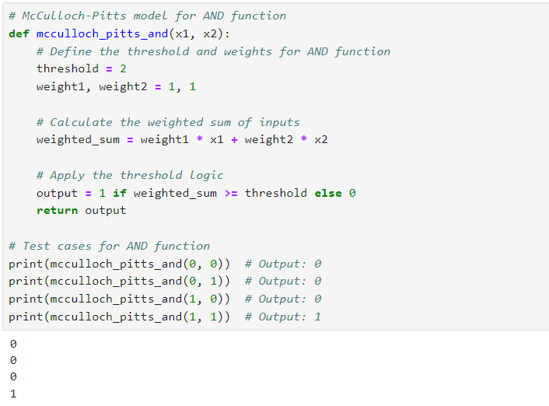

2. OR Function:

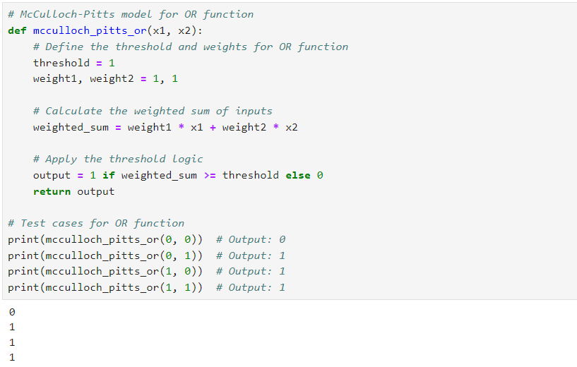

3. XOR Function:

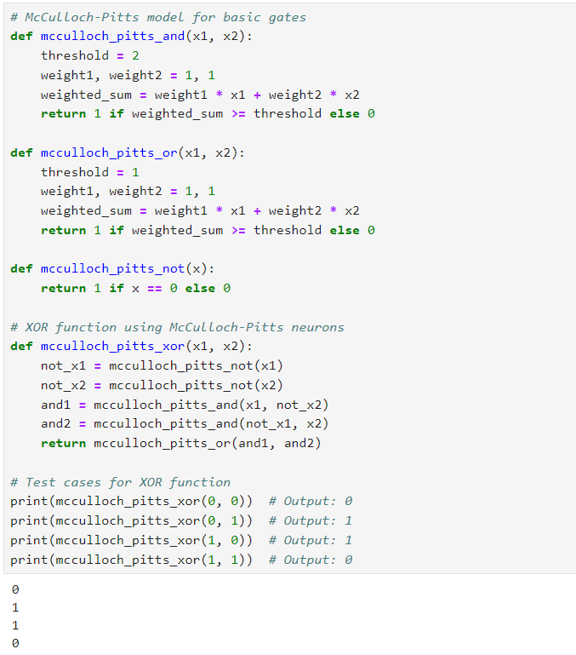

**Result & Discussion:**

1. AND Function: The model correctly outputs 1 only when both inputs are 1, demonstrating the

logical AND operation.

2. OR Function: The model outputs 1 if at least one input is 1, showcasing the OR operation.

3. XOR Function: The model outputs 1 if the inputs differ, representing the XOR operation.

**Learning Outcomes:** The student should have the ability to: Students gain foundational understanding of neural computation using McCulloch-Pitts model, solving basic logic functions

**Course Outcomes:** Upon completion of the course, students will be able to understand and use the McCulloch-Pitts model to grasp basic neural computation principles and solve logical functions (AND, OR, XOR) using threshold logic units.

**Conclusion:**

____________________________________________________________________________________________________________________________________________________________________________________________________________________________________________________________________________________________________________________________________________________________________

|  |  |  |  |  |
| --- | --- | --- | --- | --- |
| **Correction** | **Formative** | **Timely** | **Attendance /** |  |
| **Parameters** | **Assessment** | **completion of** | **Learning** |
|  | **[40%]** | **Practical [ 40%]** | **Attitude** |
|  |  |  | **[20%]** |
| **Marks** |  |  |  |
| **Obtained** |

For Faculty Use